EUROPE STUDY GUIDE—complete for 5 bonus points on your test!! You can answer on this paper, the back, or a separate piece of paper! All of this is on your notes and your human geography learning goals!!!!!!!!
PHYSICAL GEO
- Define Fjord
- Define Polder
- Define Peat/peat bog
- Where is the Rhine River?
- Where is the Danube River?
- Describe the North European Plain
- Explain location of major Peninsulas—Iberian, Balkan, Italian, Scandinavian

HISTORY
- Explain history of the Berlin Wall
- Democracy—Who created it and what is it?
- Republic—Who created it and what is it?
- Why did ancient civilizations in Europe develop around the Mediterranean?
- What is the Renaissance?
- Explain the cause and effect of the Irish Potato Famine
NORTH
- What countries make up Scandinavia?
- Explain the difference between UK and Great Britain.
- Explain Britain’s form of Government/Constitutional Monarchy
- Explain importance of the British Empire
- What was the Industrial Revolution?
MEDITERRANEAN
- Describe the role of the Pope.
- What is Rome’s cultural legacy? (Hint: Latin language)
- Climate of the area?

EAST
- Define and explain Folk art
- Define Balkanization
- Define Communism
- Define Satellite Nations and USSR
- Explain Cultural Crossroads
- Define Nationalism
WEST
- Locate “The Lowlands”
- What was the Autobahn?
- Describe the economies of France and Germany
- Explain why the Berlin Wall was put up.
- Explain the Iron Curtain.
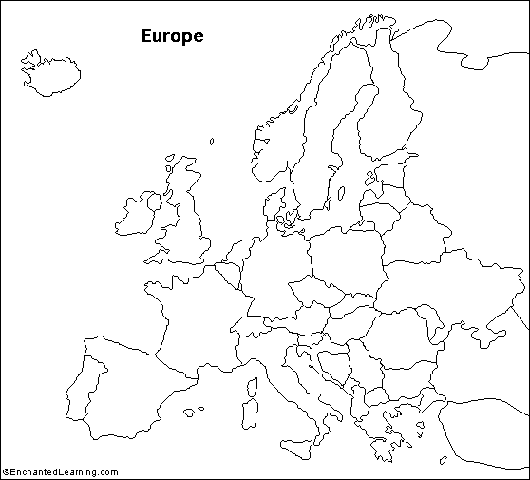
MAP ITEMS: Be able to locate the following countries and physical features on a map— Switzerland, Ukraine, Romania, Netherlands, Denmark, Czech Republic , Croatia, Norway, Sweden, Finland, Mediterranean Sea, the Alps, Danube River

