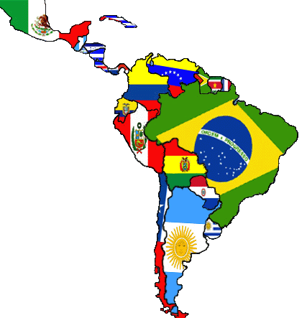
Human Geo of Latin America
NAME____________________________

MEXICO
- What country conquered Mexico? ________________________ Conqueror? ____________________________________
- What was unfair after Mexico got their independence? _____________________________________________
- What did the Institutional Revolutionary Party of 1929 do? ___________________________________________________________________________________________________
- What ancient civilization arose in the Valley of Mexico? _______________________________
Circle one: Polytheistic or Monotheistic
- “Here they practiced ______________________________________________ in their temples.”
- The capital city of the ___________, Tenochtitlan is now _______________________, the capital of _________________
- What did the Spanish leave in Mexico as their cultural legacy? ________________________________________________
- Mestizo: ___________________________________________________________________________________________
9. Name the 2 famous Mexican painters ________________________________________________________
10. What is a problem facing the Mexican economy? __________________________________________________________
11. What is NAFTA? _____________________________________________________________________________________

CENTRAL AMERICA & CARIBBEAN ISLANDS
12. The ancient civilization of the ___________________ were located in _________________________________________
13. List some things the Maya known for. ___________________________________________________________________
13. Who colonized most of Central America? _______________ until when? __________
What resource was important to the Spanish in the Caribbean? _________________________
14. Which European country had the most colonies in the Caribbean? _________________ 2nd most? _______________
15. What is an informal economy? _________________________________________________________________________
16. What type of music combines musical elements of Africa, Spain, and the Caribbean? _____________________________
17. Where and when did reggae develop? _______________________
It often has messages about _____________________________ and _________________________________

SPANISH-SPEAKING SOUTH AMERICA
18. Where did the Inca live? ______________________________________________________________________________
19. Invaded and conquered by Francisco ________________________ and the _______________________________
20. Quechua: __________________________________________________________________________________________
21. What animal was important to the Incan civilization? _____________________________
22. What is Machu Picchu? _______________________________________________________________________________
23. What is an oligarchy? _________________________________ What type of rule did they use? _____________________
When did South America have military oligarchies? _____________________________________________________
24. How would you describe art of South America? ___________________________________________________________
25. Name 2 advantages that helps South America’s economy ___________________________________________________
26. What rate is higher in South America than any other Latin American region? ____________________________________
What is this? ____________________________________________________________________________________

BRAZIL
27. What did the Treaty of Tordesillas do? ___________________________________________________________________
28. What were colonizers originally looking for in Brazil? _______________________________________________________
What was there back-up plan for profit? ______________________________________________________________
29. How did Brazilians make it known they wanted independence? _______________________________________________
30. Describe Brazil’s economy: ____________________________________________________________________________
31. Name 3 natural resources of Brazil. _____________________________________________________________________
32. Brazilian culture is a mixture of _________________________________________________________________________
Why? __________________________________________________________________________________________
33. Language: _______________________Brazil has the largest what in the world? _________________________________
34. Describe Carnival. ___________________________________________________________________________________
_____________________________________________________________________________________________________
35. A Brazilian dance with African influences __________________________________

A martial arts and dance that developed in Brazil by
African slaves who were hiding their fight training. __________________________________

This sport is a huge part of Brazil and their national team holds many titles. ______________________________
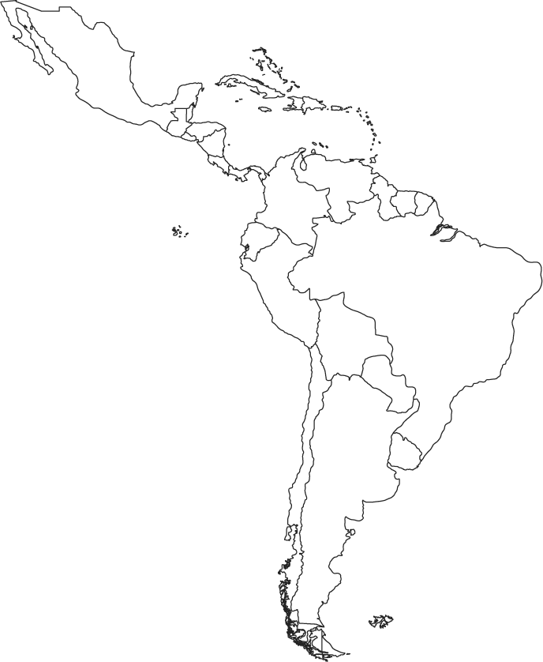

Circle and label the sub regions of Latin America: Mexico, Central America & the Caribbean, Spanish-speaking South America, and Brazil

